DESIGN AND IMPLEMENTATION OF AN EXPERT SYSTEM FOR STUDENT USE IN THE SCHOOL OF NURSING, CARITAS UNIVERSITY

BY
OKAM, SOMTO CHINAGOROM
CS/2022/1324

SUBMITTED TO
THE DEPARTMENT OF COMPUTER SCIENCE FACULTY OF NATURAL SCIENCES CARITAS UNIVERSITY, AMORJI-NIKE, ENUGU

IN PARTIAL FULFILMENT OF THE REQUIREMENTS FOR THE AWARD OF
BACHELOR OF SCIENCE (B.SC) DEGREE IN COMPUTER SCIENCE
AUGUST, 2026

DECLARATION
I, OKAM, SOMTO CHINAGOROM, with registration number CS/2022/1324, hereby declare that this project titled "Design and Implementation of an Expert System for Student Use in the School of Nursing, Caritas University" is my original research work carried out under the supervision of Dr. Ugochukwu Nwankwo Corneliu of the Department of Computer Science, Caritas University, Amorji-Nike, Enugu. The work reported herein has not been presented, in whole or in part, to any institution for the award of any other degree or qualification, and all sources consulted have been duly acknowledged.
________________________________ ________________________

Okam, Somto Chinagorom Date
(CS/2022/1324)

APPROVAL
This is to certify that we have read, examined and found this project titled "Design and Implementation of an Expert System for Student Use in the School of Nursing, Caritas University", carried out by OKAM, SOMTO CHINAGOROM with registration number CS/2022/1324, to be satisfactory and acceptable for the award of a Bachelor of Science (B.Sc) degree in Computer Science of Caritas University, Amorji-Nike, Enugu, and hence we have caused our names and signatures to appear as follows:
________________________________ ________________________

Dr. Ugo Nwachukwu Date
(Project Supervisor)
________________________________ ________________________

Mr. Ugwu, Ejike Date
(Head of Department)
________________________________ ________________________

Prof. Fergus Onu Date
(External Examiner)

DEDICATION
This project is dedicated to Almighty God, the giver of wisdom and understanding, for His grace and guidance throughout the course of this programme, and to my family, whose patience, encouragement and unfailing support made this academic journey possible.

ACKNOWLEDGEMENTS
I extend my sincere gratitude to God Almighty for the strength, wisdom and good health that sustained me throughout the duration of this project.
My profound appreciation goes to my Project Supervisor, Dr. Ugochukwu Nwankwo Corneliu, whose guidance, patience and constructive criticism shaped this work from conception to completion.
I am equally grateful to the Head of the Department of Computer Science, Mr. Ugwu, Ejike, for his leadership and support throughout the programme. My sincere thanks go likewise to Prof. Arinze Nwaeze, Dr. Henry Nweke and Dr. Ugochukwu Nwankwo Corneliu, and to all the other lecturers of the Department of Computer Science, Caritas University, for the knowledge imparted to me over the course of my studies.
Finally, I thank my family and friends for their encouragement, understanding and support throughout the period of this project.

ABSTRACT
The Nursing Student Academic Advisory Expert System is a rule-based advisory tool developed for the School of Nursing, Caritas University, Amorji-Nike, Enugu. It was built to structure the way a nursing student's academic standing, specialization fit, clinical-placement eligibility and graduation pathway are assessed. The system replaces the periodic, manual review presently conducted by academic advisers with an always-available tool a student can consult directly. It aims to deliver transparent, explainable and traceable advisory guidance.
The department's former arrangement left students without any means of checking their own standing between advising sessions. A student who had fallen behind on credit units, failed a prerequisite blocking a clinical placement, or drifted below the required CGPA had no way of discovering this until a periodic, hand-checked review eventually caught it, and no accompanying explanation of why a given piece of advice applied.
The study aimed to give a nursing student rule-based, explainable feedback across academic standing, specialization fit, clinical-placement readiness and graduation pathway, with every recommendation traceable to a specific rule and scored for how strongly the record supports it. Specific objectives included a knowledge base of explicit IF/THEN advisory rules, a forward-chaining inference engine with certainty-factor scoring, an explanation facility, a graduation-readiness score and degree-audit view, and a read-only administrative view for browsing individual student records.
Development adopted the Expert System Development Life Cycle, moving through problem identification, knowledge acquisition, knowledge representation, inference-engine design, implementation, and testing and validation against known student records.
Software, tools, and database: HTML, CSS and JavaScript for a self-contained, client-side single-page application, with structured in-browser data collections as the data store; no server, database or external front-end framework was used.
Results: The system correctly derived a student's structured facts from raw grade records and matched them against the knowledge base, assigning every fired rule a certainty factor bounded between fifty-five and ninety-seven per cent, and produced a graduation-readiness score and degree-audit view consistent with each record. Rule outcomes were verified against known student scenarios spanning all five academic levels, and representative users completed a full advisory analysis, from grade entry to printable report, without assistance.
TABLE OF CONTENTS
Title Page i
Declaration ii
Approval iii
Dedication iv
Acknowledgements v
Abstract vi
Table of Contents vii
CHAPTER ONE: INTRODUCTION 1
1.1 Background of the Study 1
1.2 Statement of the Problem 2
1.3 Aim and Objectives of the Study 3
1.4 Significance of the Study 4
1.5 Scope of the Study 5
1.6 Limitations of the Study 6
CHAPTER TWO: LITERATURE REVIEW 8
2.1 Introduction 8
2.2 Expert Systems and Rule-Based Reasoning 8
2.3 Certainty Factors and Reasoning Under Uncertainty 9
2.4 Expert System Development Methodology 9
2.5 Learning Analytics and Academic Early-Warning Systems 10
2.6 Role-Based Access Control 11
2.7 Client-Side Web Implementation 12
2.8 Usable Interface Design 13
2.9 Summary and Research Gap 13
CHAPTER THREE: SYSTEM ANALYSIS AND METHODOLOGY 15
3.1 Data Gathering 15
3.2 Research Methodology and Justification 15
3.3 System Analysis 17
3.3.1 Analysis of the Existing System 17
3.3.2 Analysis of the Proposed System 18
3.4 Justification of the Proposed System 19
CHAPTER FOUR: SYSTEM DESIGN AND IMPLEMENTATION 21
4.1 Design and Specification of the Proposed System 21
4.1.1 Input Design and Specification 22
4.1.2 Output Design and Specification 23
4.1.3 Security Design and Specification 24
4.1.4 Data Design and Specification 25
4.2 System Development Tools and Justification 26
4.3 System Requirements 29
4.3.1 Hardware Requirements 29
4.3.2 Software Requirements 30
4.4 Implementation of the Proposed System 31
CHAPTER FIVE: SUMMARY, CONCLUSION AND RECOMMENDATIONS 33
5.1 Summary 33
5.2 Conclusion 33
5.3 Recommendations 34
REFERENCES 36
APPENDIX A: SOURCE CODE SNIPPETS 37
APPENDIX B: SAMPLE OUTPUTS (SCREENSHOTS) 39

CHAPTER ONE
INTRODUCTION
1.1 Background of the Study
Nursing education places unusually compounded demands on a student. Beyond the coursework common to any degree, a nursing student must clear a sequence of foundational science courses before advancing to specialty clinical courses, must meet a minimum grade point average and prerequisite requirement before being permitted into clinical practicum placement, and must accumulate credit units at a pace that keeps a five-level programme on schedule for on-time graduation. At the School of Nursing, Caritas University, Amorji-Nike, Enugu, a student’s standing against these requirements is presently established through periodic review by academic advisers and departmental staff, cross-checking a student’s transcript against the curriculum requirements by hand.
This arrangement places the burden of noticing a problem on a review that happens only periodically, rather than on a system the student can consult at will. A student who has fallen behind on credit units, who has failed a prerequisite that now blocks a clinical placement, or whose grades cluster strongly enough in one area to suggest a particular specialization, has no way to discover this for themselves between advising sessions. It was this gap, the absence of an always-available, rule-based means by which a nursing student could check their own academic standing and receive specific, reasoned advisory guidance, that prompted the system reported in this project.
The Nursing Student Academic Advisory Expert System is proposed as a response to this gap. Rather than replacing the academic adviser, it gives a student immediate, rule-based feedback on four fronts, academic standing, specialization fit, clinical-placement readiness and graduation pathway, each recommendation traceable to an explicit rule and accompanied by an explanation of why it was given and how strongly the record supports it. A parallel administrative view allows departmental staff to open the same dashboard for any individual student, so that the tool serves both the student checking their own progress and the staff member reviewing a caseload.
The five academic levels through which a nursing student progresses at the School of Nursing each carry their own mix of foundational, core and clinical-track courses, and a student's standing against curriculum requirements therefore changes shape from one level to the next: a 100-level student is chiefly concerned with foundational science prerequisites, while a 400- or 500-level student is chiefly concerned with clinical-placement eligibility and the credit-unit pace needed to graduate on schedule. A single static checklist cannot serve every level equally well, which is why the system reported here reasons over a student's actual record rather than presenting a one-size-fits-all checklist.
This background also explains why the four advisory categories named throughout this report, Academic Standing, Specialization Guidance, Clinical Readiness and Graduation Pathway, were chosen as the system's organising structure rather than some other grouping. Each corresponds to a distinct question a nursing student or an adviser already asks under the existing manual arrangement, is my CGPA healthy, which specialty suits my strengths, am I eligible for placement, am I on pace to graduate, and each is answerable from the same underlying grade record without requiring information the department does not already collect. The four categories are accordingly not a novel classification invented for this project but a formalisation of a distinction already implicit in how academic advising is presently conducted.
1.2 Statement of the Problem
The School of Nursing, Caritas University, lacks a rule-based, always-available means by which a student can check their own academic standing, specialization fit, clinical-placement eligibility and graduation pathway. Because this review is presently conducted periodically and by hand, a student who has fallen behind on required credit units, failed a prerequisite that blocks a clinical placement, or drifted below the CGPA required for good standing, has no way of discovering this for themselves between advising sessions. This single problem, the absence of an immediate, explainable, rule-based advisory check, gives rise to delayed detection of at-risk academic standing, uncertainty among students about their eligibility for clinical placement, and the loss of an opportunity to catch a problem early enough to act on it.
These consequences are not evenly distributed across the student population. A student who is already attentive to their own progress, who keeps an informal personal record of grades and credit units, is comparatively insulated from the problem; a student who is not, whether from inexperience, workload or simple unfamiliarity with the curriculum's structure, is the one most exposed to a late-discovered probation risk or a clinical placement blocked at the point it is needed rather than in time to plan around it. A rule-based advisory tool of the kind proposed in this study narrows this gap in outcomes by making the same explicit, rule-derived check available to every student on equal terms, independent of how diligently they track their own record by hand.
This equity argument is not incidental to the study but central to its motivation. A department's academic advising exists to serve every student under its care, not chiefly the subset already equipped, by disposition or prior experience, to track their own progress; a tool that closes the gap between these two groups therefore advances a goal the existing manual arrangement, however well-intentioned, structurally cannot: consistent, rule-derived guidance available to a struggling student on exactly the same terms as to a confident one.
1.3 Aim and Objectives of the Study
The aim of this study is to design and implement the Nursing Student Academic Advisory Expert System, a rule-based expert system that reasons over a nursing student's academic record and provides advisory guidance on academic standing, specialization fit, clinical-placement readiness and graduation pathway for the School of Nursing, Caritas University, Amorji-Nike. The objectives are to:
1. Design the architecture of a rule-based advisory system suited to the curriculum structure and academic requirements of the School of Nursing, Caritas University, Amorji-Nike.
2. Develop a knowledge base of explicit, IF/THEN advisory rules across four categories, Academic Standing, Specialization Guidance, Clinical Readiness and Graduation Pathway, so that every piece of advice the system gives traces back to a specific, readable rule.
3. Develop an explanation facility, a graduation-readiness score and a degree-audit view that together make every recommendation traceable to the exact fact and rule behind it, and summarise how on-track a student is and which courses remain outstanding.
4. Implement the system using an expert-system approach, a forward-chaining inference engine with certainty-factor scoring, to evaluate a student's academic performance and generate advisory output, together with a read-only administrative view through which departmental staff may browse a roster of students.
Taken together, these four objectives correspond to the four deliverables against which the completed work is assessed in Chapter Five: a documented knowledge base, a working inference engine with certainty-factor scoring, an explanation facility paired with a graduation-readiness score and degree-audit view, and a functioning student/administrator system. Each objective was treated, in the manner set out in Chapter Three, as a unit of work to be designed, implemented and individually verified before the next was begun, rather than as a description to be satisfied only in the aggregate.
1.4 Significance of the Study
The completion of this study carries practical benefit for several groups within and beyond the department.
For students, the system removes the need to wait for a periodic advising session before a problem is noticed. Every recommendation is presented together with the exact rule and fact behind it rather than as an unexplained verdict, and a student can check clinical-placement eligibility and graduation pathway at any time rather than only when an adviser is available.
For the School of Nursing, the system supports staff oversight: the administrative roster view lets departmental staff review any individual student's standing, on a read-only basis, without reconstructing it from a transcript by hand, narrowing the window in which a student's difficulty could go unnoticed between periodic reviews.
For academic advisers, the explanation facility means a recommendation can be checked against its originating rule and fact rather than taken on trust, so the tool supports, rather than replaces, the adviser's own judgement.
This relationship between the system and the adviser is worth stating precisely, since it bears directly on how the tool should be read by anyone assessing its contribution. The system does not attempt to model the full range of judgement an experienced adviser brings to a conversation with a struggling student, sensitivity to circumstance, tone, and the many considerations that sit outside a transcript; it attempts, more narrowly, to make the transcript-derived portion of that judgement, the part that is already rule-governed in principle even when applied informally in practice, available to the student directly and consistently. The two are complementary rather than competing: the system handles the mechanical, rule-derived check so that the adviser's own time and judgement can be spent on the considerations a rule cannot capture.
For the academic community, the study demonstrates a lightweight, explainable alternative to the large, statistically modelled learning-analytics tools that dominate the literature, and provides a reference implementation of rule-based advisory reasoning, certainty-factor scoring and an explanation facility that other students and developers may extend.
Beyond these immediate beneficiaries, the study has a bearing on the wider question of how a Nigerian university department with limited technical infrastructure might improve academic advising without the capital outlay a server-backed, institution-wide system would require. By demonstrating that a meaningful advisory tool can be built, tested and deployed as a static, framework-free client-side application at negligible running cost, the study offers the department a low-risk starting point from which a fuller, server-backed deployment, should the department choose to pursue one, can be planned with the rule base and inference logic already proven rather than designed from a blank page.
1.5 Scope of the Study
This project covers the design, implementation and evaluation of a rule-based expert system that runs in a standard web browser, built around a representative nursing curriculum spanning five academic levels. In concrete terms, the system's scope covers five parts. First, a knowledge base of fourteen advisory rules across the four categories named in Section 1.3. Second, a forward-chaining inference engine, paired with certainty-factor scoring and an explanation facility, that matches a student's derived facts against those rules. Third, a graduation-readiness score and a degree-audit view, built from the same underlying facts. Fourth, a printable advisory report that a student can save or share. Fifth, an administrative area, gated behind a demonstration sign-in, through which departmental staff may browse a roster of students and view any one student's dashboard on a read-only basis. The system is intended for use by the students and academic staff of the School of Nursing, Caritas University.
The study is bounded as follows. It concerns the reasoning over, and presentation of, a student’s academic record within a single client-side application, and does not undertake clinical diagnosis, patient-facing decision support, or the formal administration of examinations and results. The curriculum against which it reasons is a representative sample built to demonstrate the system rather than a live export of the department’s official course catalogue; connection to the university’s actual student-records system is identified in Section 5.3 as further work rather than undertaken here.
The five-part scope stated above was also treated as a fixed contract against which feature creep was deliberately resisted during implementation. Several extensions suggested themselves during development, a messaging feature to notify a student of a newly fired rule, for instance, or a comment field through which an adviser could annotate a student's dashboard, and each was set aside, not because it lacked merit, but because it fell outside the five parts named in Section 1.5 and was accordingly redirected into the recommendations for further work in Section 5.3 rather than absorbed into the present build.
This boundary was set deliberately rather than as an oversight. A system that reasons over academic records sits close enough to a student's wellbeing that it would be irresponsible to extend its scope, within a single undergraduate project and without institutional review, into territory such as counselling referral or disciplinary flagging; the system is confined to advisory guidance drawn transparently from academic rules, and any extension toward more consequential decisions is left, deliberately, outside the scope stated here.
1.6 Limitations of the Study
Several factors constrained the execution of this work and should be borne in mind when interpreting its results:
• The system holds its curriculum and student records in structured in-browser collections rather than in a server-side database. This lets every view be demonstrated at realistic scale, but a change made in one session, a grade entered or edited, is not written to a persistent store and does not survive a page reload, because no server or database is provisioned in this build. The introduction of a persistence layer is identified in Section 5.3 as the first priority for further work.
• Administrative sign-in in the present build is performed within the browser against a single shared demonstration password, intended to exercise the student/administrator access distinction rather than to secure real staff accounts. Per-staff credentials verified on a server are likewise identified as further work.
• The student roster available to the administrative view is a small set of representative demonstration records, built to exercise the rule base across different scenarios, rather than the department's actual student population.
• The study was carried out within a single academic session alongside coursework and examinations, which constrained the duration of the evaluation exercise.
None of these limitations bears on the correctness of the reasoning the system performs; each concerns the scale, the security posture, or the duration at which the system was demonstrated rather than the soundness of its rule base or inference engine. They are stated here, in the interest of the same transparency the system itself is built to provide, so that a reader evaluating the work knows precisely which claims are supported by the present build and which are identified, in Section 5.3, as further work for a production deployment.
CHAPTER TWO
LITERATURE REVIEW
2.1 Introduction
This chapter reviews the body of literature relevant to the design of a rule-based academic advisory expert system. It begins with the theory of expert systems and rule-based reasoning, on which the present system’s core architecture rests, and with the treatment of uncertainty through certainty factors. It then turns to expert system development methodology, to the related field of learning analytics and academic early-warning systems, and finally to the technical foundations of the implementation: role-based access, client-side web development and usable interface design. Each body of work is related to the present project, with its contribution and its limitation identified, and the chapter concludes by stating the gap that the study addresses.
Situating the present chapter within the wider structure of this report, the literature reviewed below is drawn on again directly in later chapters: the expert-systems and certainty-factor material of Sections 2.2 and 2.3 underlies the inference engine designed in Section 4.1, the methodology material of Section 2.4 underlies the ESDLC justification given in Section 3.2, and the access-control and interface material of Sections 2.6 to 2.8 underlies the security and interface design of Sections 4.1.3 and 4.1.2 respectively. The chapter is organised in this order so that a reader encounters each body of theory immediately before the chapter that applies it, rather than as a self-contained survey read in isolation from the system it informs.
2.2 Expert Systems and Rule-Based Reasoning
An expert system is a computer program that emulates the decision-making of a human expert within a narrow domain by reasoning over a base of explicitly represented knowledge rather than by following a fixed procedural script (Jackson, 1998). Buchanan and Shortliffe (1984), reporting on MYCIN — a name derived not from an acronym but from the “-mycin” suffix common to antibiotic names — among the earliest and most influential rule-based expert systems, built to recommend antimicrobial therapy — establish the now-standard architecture of a knowledge base of IF/THEN rules, an inference engine that matches facts against those rules, and an explanation facility that can state why a given conclusion was reached. This architecture is directly adopted in the present system: Chapter Four documents an equivalent separation between the knowledge base of fourteen advisory rules, the forward-chaining inference engine that matches a student’s derived facts against them, and an explanation facility that states, for every fired rule, the specific fact that triggered it. Giarratano and Riley (2005) reinforce this architecture and add that a defining strength of the rule-based approach, relative to an opaque statistical or learned model, is that its reasoning is inspectable: every conclusion can be traced back to the exact rule that produced it. This traceability is precisely what the present system’s explanation facility is designed to expose to a student rather than to keep hidden inside the system.
2.3 Certainty Factors and Reasoning Under Uncertainty
A rule firing on a real, sometimes borderline, record does not always warrant the same degree of confidence, and treating every fired rule as equally certain risks overstating what the data supports. Buchanan and Shortliffe (1984) address this directly in MYCIN through the certainty-factor model, in which each conclusion carries a numeric measure of confidence derived from how strongly the evidence supports it, rather than being reported as a flat true/false verdict. Negnevitsky (2005) situates certainty factors within the broader treatment of reasoning under uncertainty in rule-based systems, and observes that a well-designed certainty measure should never assert total confidence from a single, possibly incomplete, source of evidence. The present system applies this principle directly: every fired rule is assigned a certainty factor computed from how far the student’s data sits past the rule’s threshold, bounded between fifty-five and ninety-seven per cent, so that a borderline CGPA produces a lower confidence figure than a CGPA clearly below the probation threshold, and no recommendation is ever presented as absolutely certain.
2.4 Expert System Development Methodology
Jackson (1998) and Turban, Aronson and Liang (2005) set out the life cycle by which an expert system is customarily built: problem identification, to bound the domain the system will reason about; knowledge acquisition, to gather the rules an expert would apply; knowledge representation, to encode those rules in a form the system can execute; inference-engine design, to determine how the represented rules will be matched against facts; implementation; and testing and validation against known cases. This life cycle, generally referred to as the Expert System Development Life Cycle, is the methodology adopted for the present work and is detailed, with justification, in Section 3.2. It is distinguished from a general-purpose methodology such as the Object-Oriented Analysis and Design Methodology by its explicit separation of the knowledge base — the rules an expert would state — from the mechanism that reasons over it, a separation that maps directly onto the present system’s division between its rule base and its inference engine.
A recurring difficulty noted in the expert-systems literature at the knowledge-acquisition stage is what is often termed the knowledge-acquisition bottleneck: the process of eliciting an expert's implicit judgement and restating it as an explicit, testable rule is slow and error-prone, particularly where the expert's own reasoning is intuitive rather than already rule-shaped. The present project was comparatively insulated from this difficulty because the advisory domain, academic standing, specialization fit, clinical eligibility and graduation pathway, is already governed by explicit, published thresholds, a minimum CGPA, a required prerequisite, a credit-unit target, rather than by tacit expert judgement that must first be drawn out through extended interview. Knowledge acquisition for this project accordingly consisted chiefly of gathering and cross-checking these published thresholds against the curriculum, described further in Section 3.1, rather than the more open-ended elicitation exercise the literature usually treats as the harder case.
A related methodological point made in the literature is that a rule-based system's knowledge base should be validated against known cases before, rather than only after, it is connected to an interface, precisely so that a defect in the reasoning is caught while it is still cheap to fix. Turban, Aronson and Liang (2005) treat this as a distinct verification stage separate from the broader validation that closes the ESDLC. The present project observed this distinction directly: the case-by-case testing described in Section 4.4 was conducted entirely against the bare inference engine, run from the command line against representative records, before the student and administrative interfaces were built on top of it, so that a rule's correctness was never confounded with the correctness of the interface rendering its output.
2.5 Learning Analytics and Academic Early-Warning Systems
The broader field of learning analytics concerns the use of a student’s data to identify academic risk and to guide intervention before it is too late to act. Arnold and Pistilli (2012), reporting on Purdue University’s Course Signals system, describe an early-warning tool that combines a student’s grades, effort and demographic data into a risk indicator surfaced to the student and their instructor, and report a measurable association between its use and improved student retention. Siemens and Long (2011) situate such systems within the wider promise of learning analytics: that data already held by an institution can be turned into timely, actionable guidance rather than left to inform only a retrospective review. These works establish that the underlying idea — turning a student’s academic data into a timely, actionable signal — is well founded and has been shown to help. Their limitation, for the present project, is architectural rather than conceptual: systems of this kind are typically large, statistically modelled tools integrated into an institution’s learning-management system, and their risk indicator is generally opaque to the student, in contrast to a rule-based system whose every recommendation can be explained. The present system pursues the same goal of timely, actionable academic guidance, but through an explicitly rule-based, explainable and independently deployable design that a single undergraduate project can realistically build and defend.
Arnold and Pistilli (2012) further describe Course Signals' use of a simple traffic-light indicator, red, amber or green, to summarise a student's risk level for the student and the instructor, a device intended to make a statistically derived risk score legible without requiring either party to interpret the underlying model. The present system pursues the same legibility goal by a different route: rather than compressing a statistical model's output into a single colour, it exposes the specific rule and fact behind each recommendation directly, so that legibility is achieved through transparency of reasoning rather than through simplification of an otherwise opaque score.
A further point of contrast is worth drawing out. A statistically modelled early-warning system of the kind Arnold and Pistilli (2012) describe typically requires a substantial history of prior-cohort data before its model can be trained and trusted, which is a genuine barrier for a department without an existing data-analytics function. A rule-based system of the kind built here requires no such training history: its rules are written directly from the department's published academic thresholds, described in Section 3.1, and can therefore be deployed usefully from the department's very first cohort of users, at the cost of the more limited, purely threshold-based reasoning a statistical model's pattern-detection would otherwise provide.
2.6 Role-Based Access Control
The mechanism by which the present system distinguishes an ordinary student session from an administrative one derives from the model of Role-Based Access Control formalised by Sandhu, Coyne, Feinstein and Youman (1996), in which permissions are assigned to roles rather than to individual users. The present project applies the principle in a deliberately minimal form: a student session may view and edit only its own record, while an administrative session, reached through a separate sign-in, may view — but not edit — the dashboard of any student in the roster. The honest limitation, relative to the full model, is that the present build enforces this distinction in client-side code against a shared demonstration credential rather than through server-side, per-account authorisation; extending it to real staff accounts with server-side enforcement is identified in Section 5.3 as further work.
Sandhu, Coyne, Feinstein and Youman (1996) set out a family of models of increasing sophistication, from a base model in which permissions attach to roles, through models that add role hierarchies, in which a senior role inherits the permissions of a junior one, to a model that adds constraints such as separation of duty. The present system's two-role distinction, an ordinary student role and a read-only administrative role, corresponds to the base model in this family rather than to a hierarchy or a constrained model, since a departmental staff member's administrative session does not inherit or extend a student session but instead reaches an entirely separate, read-only view. A production deployment with multiple categories of staff, an adviser role able to leave notes and a registrar role able to certify a graduation audit, for instance, would need the fuller hierarchical model the literature describes.
2.7 Client-Side Web Implementation
The system is implemented without a front-end framework, directly against the browser’s document model. Flanagan (2020) describes JavaScript as the language of the web platform and the Document Object Model as the interface through which a script reads and modifies the structure and content of a page. The present system uses exactly this approach: plain JavaScript derives a student’s facts, matches them against the rule base, and constructs each vitals card, advisory card and roster row directly, without an intermediate library. The merit of this framework-free approach, at the present scale, is a small, dependency-free artefact that deploys as a static site with no build step; its limitation, which the literature also notes, is that hand-written DOM manipulation becomes harder to maintain as an application grows, which is why a framework is usually adopted at a larger scale than the present system occupies.
Flanagan (2020) additionally emphasises the cost of frequent, unbatched DOM manipulation, each direct change to the page's structure can force the browser to recompute layout, and recommends constructing a section of interface in memory before inserting it into the document in a single operation. The present system follows this guidance: each vitals card, advisory card and roster row is built as a complete, detached element before being appended to the page, rather than being assembled through a sequence of incremental changes to elements already on screen, which keeps the interface responsive even though no framework's batching layer is present to enforce this discipline automatically.
2.8 Usable Interface Design
Because the system is intended to be read and understood quickly by a student checking their own standing, the usability of its interface is a genuine design concern. Nielsen (1993) sets out heuristics for user-interface design — among them visibility of system status and the recognition of information rather than its recall — which informed the design of the vitals strip and the readiness score, both of which surface a student’s standing at a glance rather than requiring it to be inferred from the raw record. Shneiderman and Plaisant (2010) add the influential principle of overview first, then detail on demand, which maps directly onto the present interface: the readiness score and vitals give an overview, and each advisory card expands, through its explanation toggle, to the specific reasoning behind it only when the student asks for it.
Shneiderman and Plaisant's earlier and closely related eight golden rules of interface design, consistency, informative feedback, and the reduction of short-term memory load among them, are likewise reflected in the present interface: the same card layout and colour convention is used for every advisory category so a student learns the pattern once, and the vitals strip keeps the record's key figures visible on screen rather than requiring the student to hold them in memory while reading the advisory cards below. Nielsen's heuristic of error prevention was applied at the level of the input design described in Section 4.1.1, where a grade is entered through a constrained drop-down control rather than free text, which forecloses an entire class of malformed-input error before it can occur.
2.9 Summary and Research Gap
The literature reviewed establishes that a rule-based expert system rests on a knowledge base, an inference engine and an explanation facility (Buchanan & Shortliffe, 1984; Giarratano & Riley, 2005); that a well-designed system should express its confidence rather than overclaim it (Negnevitsky, 2005); that such a system is properly built through a life cycle of problem identification, knowledge acquisition, representation, inference-engine design, implementation and validation (Jackson, 1998; Turban et al., 2005); that turning academic data into a timely signal is a well-founded goal (Arnold & Pistilli, 2012; Siemens & Long, 2011); that sensitive views should be gated by role (Sandhu et al., 1996); and that the interface should be built against established usability heuristics (Nielsen, 1993; Shneiderman & Plaisant, 2010) using the tools the browser natively provides (Flanagan, 2020).
Two gaps are nonetheless evident. First, the expert-systems literature is written largely around domains such as medical diagnosis and offers comparatively little worked guidance for academic advising specifically, while the learning-analytics literature that does address academic advising is generally realised as large, statistically modelled, institution-integrated software rather than as a transparent, rule-based system a student can inspect rule by rule. Second, little existing work combines explicit rule-based reasoning, certainty-factor scoring and a genuine explanation facility in a single lightweight tool addressed specifically to nursing academic advising — covering standing, specialization, clinical readiness and graduation pathway together — built without server infrastructure by a single undergraduate. This study addresses both gaps by designing, implementing and evaluating such a system, honestly scoped to what a client-side rule-based prototype provides and clear about the server-side extensions a production deployment would require.
The gap this study addresses is accordingly a narrow one, but it is a real one. It is not claimed that rule-based reasoning is superior to statistically modelled learning analytics in general, the two serve different purposes and different data conditions, but rather that for a specific, well-bounded advising domain governed by explicit, published thresholds, a transparent, rule-based tool is both sufficient and, for the reasons of legibility and low deployment barrier discussed above, preferable to the heavier statistical alternative the wider learning-analytics literature tends to assume.
CHAPTER THREE
SYSTEM ANALYSIS AND METHODOLOGY
3.1 Data Gathering
The data used to inform the design of this system were gathered through direct observation, informal interview and the study of documentation. Observation of how a nursing student’s academic standing is presently reviewed at the School of Nursing revealed the day-to-day practice the system seeks to improve: periodic, manual checking of a student’s transcript against curriculum requirements by academic advisers and departmental staff, with no tool a student could consult independently between such reviews. This observation was supplemented by informal conversation about the requirements nursing students are expected to meet — the credit-unit pace expected of each level, the CGPA and prerequisite conditions attached to clinical placement, and the broad specialty tracks a student might be guided toward — and by a review of published literature on expert systems, certainty-factor reasoning and learning analytics, as set out in Chapter Two. Together, these sources established both the problem to be solved and the accepted principles for solving it.
The interviews were kept deliberately informal and unstructured, in keeping with the small scale of an undergraduate project, but were still directed toward specific questions: what CGPA threshold separates good standing from probation risk, which courses are treated as clinical-practicum prerequisites and at what point in the programme they are ordinarily taken, how a specialization track is informally suggested to a student under the present arrangement, and what pace of credit-unit accumulation is expected of a student at each of the five levels. The answers gathered against each question were subsequently cross-checked against the department's published curriculum structure before being encoded as knowledge-base rules, so that no rule in the finished system rests on a single, unverified account of departmental practice.
Data gathering also extended to the shape of the curriculum itself, which was reconstructed course by course, level by level, from the department's published programme structure, noting for each course its credit-unit weight, its subject category and whether it is designated core or a clinical-practicum prerequisite. This reconstructed curriculum, rather than a live export from a student-records system, is the reference structure against which the system's rules are ultimately tested, and its representative rather than official status is stated plainly as a limitation in Section 1.6.
3.2 Research Methodology and Justification
The methodology adopted for this work is the Expert System Development Life Cycle (ESDLC). Under this methodology, the problem domain is treated as a set of expert-stated rules to be captured, represented and reasoned over by an inference engine, rather than as a set of collaborating objects or a strictly sequential set of processing stages. ESDLC was chosen for three reasons. First, the problem domain is naturally rule-shaped: an academic adviser’s guidance to a nursing student — concerning probation risk, specialization fit, clinical eligibility and graduation pace — is most faithfully captured as a set of explicit IF/THEN statements, which is exactly the representation ESDLC is built around. Second, ESDLC’s explicit separation of knowledge acquisition and representation from inference-engine design maps directly onto the structure of the built system, in which the rule base is a distinct, independently readable module from the engine that reasons over it — a separation neither the Waterfall model nor the Object-Oriented Analysis and Design Methodology insists upon. Third, ESDLC’s final stage of testing and validation against known cases suited the way the system was actually built and verified: each rule was tested against representative student records before being wired to the interface, as described in Section 4.4. In accordance with this methodology, the system architecture, the ESDLC stages as applied to this project, and the inference process are documented as diagrams in Chapter Four under Section 4.2.
ESDLC was also weighed directly against two alternative methodologies before being adopted. The Waterfall model, with its strictly sequential stages of requirements, design, implementation and testing, was judged unsuitable because it does not distinguish a knowledge base from the mechanism that reasons over it, the distinction on which the present system's testability, verifying one rule at a time against known records, depends. The Object-Oriented Analysis and Design Methodology was judged unsuitable for the same reason: it organises a system around collaborating objects with encapsulated behaviour, which is a natural fit for the interface layer built in Chapter Four but not for a knowledge base whose defining property is that its rules must remain individually readable, auditable and testable in isolation from the code that executes them. ESDLC's rule-centred structure, by contrast, matches the shape of the problem domain directly.
The choice of methodology was reviewed once more after the system's design was substantially complete, as a check on whether ESDLC had, in practice, delivered the separation of concerns it promised. It had: the knowledge base, held as the array of fourteen rule records described in Section 4.1.4, remained throughout development a file a reader unfamiliar with the rest of the codebase could open and understand on its own terms, without needing to trace through the inference engine or the interface layer to make sense of any individual rule. This after-the-fact review is reported here because a methodology's suitability is properly judged by whether it delivers on its stated promise, not only by the a priori reasoning that motivated its selection.
3.3 System Analysis
3.3.1 Analysis of the Existing System
The existing system is manual and periodic in character. A nursing student’s academic standing, specialization fit, clinical-placement eligibility and graduation pathway are reviewed by academic advisers and departmental staff at scheduled intervals, by checking a student’s transcript against the curriculum’s requirements by hand. Between these reviews, a student has no tool through which to check their own standing. This manner of operation gives rise to a number of drawbacks:
• Delayed detection, since a decline in standing — a falling CGPA, a failed prerequisite — is caught only at the next scheduled review rather than as soon as it occurs.
• No self-service check, since a student cannot verify their own eligibility for clinical placement or their progress toward graduation without approaching an adviser.
• Unexplained guidance, since informal advice given in a review is rarely accompanied by a stated, traceable reason the student can revisit later.
• Uneven staff attention, since a manual review of an entire cohort’s transcripts against curriculum requirements is time-consuming and cannot be repeated as often as a change in standing might warrant.
A further, less visible drawback follows from the informality of the existing arrangement: because the substance of a review is not recorded in any structured, comparable form, it is difficult for the department itself to audit how consistently its own stated thresholds are being applied from one adviser, or one review cycle, to the next. A rule-based system, by contrast, applies the same fourteen rules identically to every student record it examines, which removes this source of inconsistency as a by-product of its design rather than as a separately engineered feature.
A short illustrative scenario makes the practical effect of these drawbacks concrete. Consider a final-year student whose CGPA has drifted, over two consecutive semesters, to just below the threshold required for continued clinical placement. Under the existing arrangement, this drift is only confirmed at the department's next scheduled review, by which point the student may already have registered for a placement they are no longer eligible to begin, creating an avoidable administrative correction and a late, stressful conversation with an adviser. It is precisely this kind of delay, between a change in standing and its detection, that the proposed system in Section 3.3.2 is designed to close.
A second, less dramatic but more frequent scenario further illustrates the drawback of uneven staff attention. A student comfortably within good standing, with no failed prerequisite and no clinical block, still receives no confirmation of this fact between scheduled reviews under the existing arrangement; reassurance, in other words, is as unavailable as warning is delayed. The proposed system addresses both cases through the same mechanism, since a rule base that fires a warning when a threshold is crossed can, with equal ease, surface a positive-severity advisory confirming that a student's standing is sound, which the existing periodic review, being effort-constrained, has no comparable capacity to provide routinely.
3.3.2 Analysis of the Proposed System
The proposed system, the Nursing Student Academic Advisory Expert System, replaces this periodic manual review with an always-available, rule-based advisory tool. A student’s grade record is matched, on demand, against a knowledge base of fourteen explicit rules across four categories — Academic Standing, Specialization Guidance, Clinical Readiness and Graduation Pathway — and every recommendation the system gives is accompanied by a certainty factor and an explanation naming the exact rule and fact behind it. A graduation-readiness score and a degree-audit view summarise the same underlying facts at a glance, and an administrative view, gated behind a sign-in, lets departmental staff open the same dashboard for any student in the roster. The major features of the proposed system are therefore its rule-based knowledge base, its forward-chaining inference engine with certainty-factor scoring, its explanation facility, its readiness score and degree audit, and its administrative roster view. The chief benefits are immediacy of feedback, transparency of reasoning, and the consolidation of four distinct advisory concerns into one dashboard.
Returning to the scenario above, the same final-year student would, under the proposed system, see a critical-severity advisory the first time their CGPA crossed the clinical-eligibility threshold, accompanied by the exact rule and the exact CGPA figure that triggered it, at whatever point they next opened the dashboard, rather than only at the department's next scheduled review. The delay between a change in standing and the student becoming aware of it is thereby reduced from the length of a review cycle to, at most, the length of time before the student next consults the system.
3.4 Justification of the Proposed System
The proposed system is justified as the appropriate solution to the problem because it addresses each of the identified drawbacks directly. Delayed detection is reduced because a student’s standing can be checked, and re-checked, at any time rather than only at a scheduled review. The absence of a self-service check is remedied because the system is available to the student directly, without requiring an adviser’s involvement to obtain a first read of their standing. Unexplained guidance is addressed because every recommendation is accompanied by a certainty factor and a rule-level explanation that can be revisited at any time, not only recalled from a conversation. Uneven staff attention is met because the administrative roster view lets a staff member open any individual student’s dashboard directly, rather than reconstructing their standing from a transcript by hand. Because every drawback of the existing arrangement is met by a corresponding feature of the proposed system, the proposed system is the well-founded solution to the stated problem. Its delivery as a rule-based, self-contained client-side application further suits an undergraduate project and a resource-constrained deployment, while leaving a clear path — a server, a database and live integration with the department’s actual student records — for a production extension.
A cost-based view of the same comparison reinforces the conclusion. The existing arrangement's cost is chiefly a recurring staff-time cost, borne every review cycle regardless of whether any student's standing has actually changed since the last one. The proposed system's cost is chiefly a one-time development cost, borne once during the work reported in Chapter Four, after which the marginal cost of an additional check, by a student or by a staff member opening the roster, is negligible. For a department reviewing an entire cohort's transcripts by hand each cycle, this shift from a recurring, per-review cost to a one-time development cost is, on its own, a material argument in the proposed system's favour, independent of the transparency and immediacy benefits already discussed.
This justification was tested, rather than merely asserted, against the counter-argument that a manual review by an experienced adviser might catch a nuance a rule-based system would miss, a specific personal circumstance behind a difficult semester, for instance. This is accepted as a genuine limit of the proposed system, and is precisely why Section 1.4 frames the system as a complement to, rather than a replacement for, the adviser's own judgement: the proposed system is justified as the appropriate first-line check, not as a substitute for the adviser wherever a nuance beyond the transcript is in play.
CHAPTER FOUR
SYSTEM DESIGN AND IMPLEMENTATION
4.1 Design and Specification of the Proposed System
This section describes the principal design processes of the system: the design of its inputs, its outputs, its security and its data. In architectural terms the system is a single-page client-side application built around four cooperating components — a working memory of facts derived from the student record, a knowledge base of explicit rules, a forward-chaining inference engine, and a user interface that renders the student and administrative views — together with an explanation facility and a certainty module that annotate each conclusion the inference engine reaches. This arrangement is illustrated in Figure 4.1.
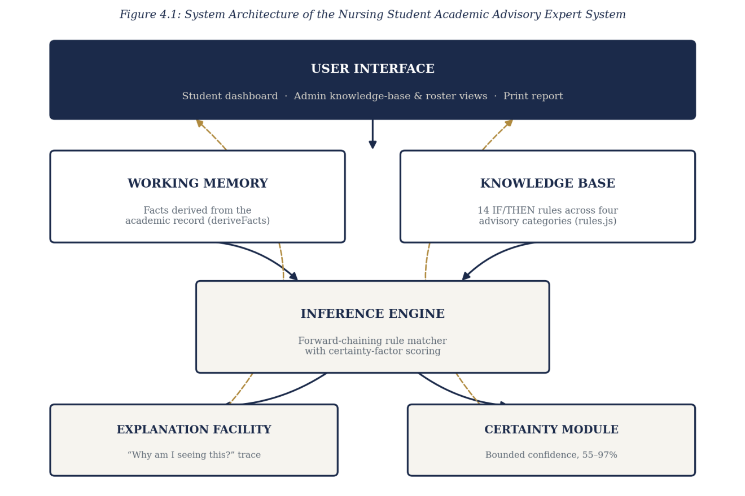
Figure 4.1: System Architecture of the Nursing Student Academic Advisory Expert System
These four components communicate through a single, unidirectional flow rather than through direct references to one another. A student's raw grade record passes into the working-memory layer, which derives structured facts from it; the inference engine tests those facts against the knowledge base and produces a set of fired rules, each carrying its own certainty factor and explanation; and the interface layer renders that set of fired rules without itself containing any advisory logic of its own. This separation means that a change to a rule's threshold, for instance, requires editing only the knowledge base, and never the interface code that displays the rule's output, which is the same separation of concerns Chapter Two identified as the defining strength of the rule-based architecture.
The explanation facility and the certainty module sit alongside, rather than inside, the inference engine proper, receiving the same fired-rule set the engine produces and annotating each entry with the fact that satisfied its condition and the computed confidence figure, before the interface layer renders the annotated set. Keeping these two concerns as a distinct annotation step, rather than folding certainty computation and explanation text directly into each rule's own definition, means a rule author writing a new IF/THEN condition, as recommended for future work in Section 5.3, need not also hand-write its explanation and certainty logic from scratch; the shared annotation step supplies both automatically from the rule's declared threshold and category.
4.1.1 Input Design and Specification
The inputs to the system are collected through interface controls presented to the user. The principal input is the academic record table, through which a student supplies a letter grade (A–F) for each course in the curriculum via a drop-down control, and a level selector through which the student’s current academic level is set. A second input is the administrative sign-in form, which collects a demonstration password. The input fields of the academic record table are summarised in Table 4.1.
Input Field | Control Type | Data Collected
Course grade | Drop-down list | Letter grade (A, B, C, D, E, F) for one curriculum course
Academic level | Drop-down list | Student’s current level (100–500)
Administrative password | Password box | Demonstration credential gating the administrative area
Each control in the academic record table constrains the student to a valid input by construction rather than by post-entry validation: the grade drop-down offers only the six letter grades in current use at the School of Nursing, and the level selector offers only the five levels defined in the curriculum, so that a malformed or out-of-range value cannot be entered in the first place. This design choice, consistent with the error-prevention heuristic discussed in Section 2.8, was preferred over accepting free-text input and validating it afterward, since a constrained control removes an entire class of input error rather than merely detecting it once made.
The administrative sign-in form's password field is the one input in the system deliberately left as free text rather than a constrained control, since a password cannot, by its nature, be offered as a fixed set of choices. This field is instead protected by the access-control measures described in Section 4.1.3 rather than by input constraint, illustrating that the two input-design strategies, constraining the control and validating what is submitted, are applied according to which is appropriate to the field in question rather than uniformly across the whole interface.
4.1.2 Output Design and Specification
The outputs of the system are the views it renders in response to the derived facts and the fired rules, designed to be consistent with the objectives stated in Chapter One. The principal output is the advisory results panel, in which each fired rule is presented as a card bearing its category, severity, certainty factor and advisory text, together with an explanation toggle that reveals the specific fact behind it. A second output is the vitals strip, presenting CGPA, credit units completed, outstanding core courses and clinical-placement blocks at a glance. A third is the graduation-readiness score, a single percentage with a four-part breakdown, and the accompanying degree-audit view listing outstanding and completed courses. A fourth is the printable advisory report, a formatted, standalone document generated from the same results for the student to save or present. The administrative roster view renders a fifth output, a summary row per student showing CGPA and readiness at a glance, from which the same dashboard views can be opened read-only for any individual student. Representative outputs are shown in Appendix B.
Each of these five outputs is derived from the same underlying set of facts computed once by the inference engine, rather than being independently recomputed for each view. This single-source-of-truth design was adopted specifically to avoid a class of defect common to systems that compute a related figure, a CGPA shown in one place and a CGPA shown in another, more than once: were the vitals strip and the degree-audit view to each perform their own CGPA calculation, the two could silently drift out of agreement if one were later edited without the other. Deriving every output from one shared fact set removes this risk by construction.
The printable advisory report deserves particular mention among the five outputs, since it is the one output designed to leave the running application entirely: rendered as a self-contained, formatted document rather than a live view, it is intended to remain meaningful to a student or an adviser who opens it days or weeks later, after the underlying record may have changed. Each report accordingly carries the date and time of its own generation alongside the advisory content, so that a reader can judge, at a glance, how current the report's figures are relative to the student's present standing.
4.1.3 Security Design and Specification
The security of the system rests on its two-area access model. By default, a user of the system operates in the student area and may view and edit only their own record. To reach the administrative area, a user must supply the demonstration password; only after this is satisfied are the knowledge-base and student-roster views reached, and the roster’s individual student dashboards are rendered strictly read-only, with no grade-editing control presented. This restriction is enforced at the level of the interface, which renders the administrative routes only after the password check succeeds and withholds the editable grade controls from the read-only roster view.
The threat this design guards against is, realistically, accidental rather than adversarial: a student navigating into a view they should not edit, or a staff member mistaking the roster's read-only dashboard for an editable one, rather than a determined attacker probing the client-side code. Because the entire application executes in the user's own browser, a technically sophisticated user could, in principle, alter the running code to bypass the password check; this is acknowledged as an inherent limit of any purely client-side security model, and is precisely why Section 5.3 recommends server-side enforcement, rather than an improved client-side check, as the appropriate remedy for a production deployment.
A further, narrower security consideration concerns the data a student can see about themselves versus the data an administrative session can see about the roster. The student view exposes only the signed-in student's own record; there is, in the present build, no route by which a student session can request another student's data, a distinction enforced by the interface never offering a control through which one student's session could address another student's record, rather than by a server-side authorisation check that does not exist in a purely client-side build. This is stated plainly rather than glossed over, since it is exactly the kind of guarantee that only a server-side implementation, as recommended in Section 5.3, can make robust against a determined attempt to circumvent it.
The prototype status of this build is reflected honestly in one respect, identified in Section 5.3 as a priority for further work: the administrative password is a single shared demonstration credential checked in client-side code, sufficient to exercise the access distinction but not to secure real staff accounts. A production deployment would require per-staff credentials verified on a server against irreversibly hashed values, together with server-side enforcement of the student/administrator distinction.
4.1.4 Data Design and Specification
The present build does not provision a server-side database. To demonstrate every view at realistic scale, the curriculum and the working student records are held in structured collections within the browser, loaded when the application starts. The logical model is nevertheless designed as a set of well-defined record types, so that migration to a server-hosted store may be effected by substituting the data source without altering the rules or the inference engine defined upon it. The curriculum record, which is the reference structure the inference engine reasons against, is specified in Table 4.2.
Field | Type | Description
code | String | Unique course code, e.g. NUR301
title | String | Course title
level | Number | Academic level at which the course is taken (100–500)
semester | Number | Semester within the level (1 or 2)
units | Number | Credit units carried by the course
category | String (enumerated) | Subject category used by specialization-guidance rules
core | Boolean | Whether the course is a required core course
clinical | Boolean | Whether the course is a clinical-practicum prerequisite
A rule record, held in the knowledge base, is specified in Table 4.3. Each rule pairs a machine-checkable condition with the advisory text, explanation and certainty computation to be produced when it fires.
Field | Type | Description
id | String | Unique rule identifier, e.g. AS-01
category | String (enumerated) | One of the four advisory categories
severity | String (enumerated) | critical, warning, positive or info
test | Function(facts) | Boolean condition evaluated against derived facts
advice | Function(facts) | Advisory text produced when the rule fires
explain | Function(facts) | Explanation naming the fact that satisfied the condition
cf | Function(facts) | Certainty factor computed from how far the fact sits past its threshold
A student record is a small structure holding a name, registration number, current level and a list of [course code, grade] pairs, from which the inference engine derives CGPA, credit-unit progress, category averages, outstanding core courses and clinical-placement blocks at the point the record is examined.
The derivation of CGPA and category averages from a student's list of course-grade pairs follows the standard weighted computation used throughout Nigerian tertiary institutions: each grade is converted to its grade-point equivalent, multiplied by the credit units of its course, summed across all completed courses, and divided by the total credit units attempted. Category averages used by the specialization-guidance rules are computed the same way but restricted to the courses tagged with a given subject category, so that a student's relative strength across categories can be compared on a like-for-like basis. Outstanding core courses and clinical-placement blocks are derived by comparing the student's completed-course list against the curriculum's core and clinical flags rather than being stored as separate, independently maintained fields, which keeps these derived figures consistent with the underlying grade record by construction rather than by manual synchronisation.
This record-type design was also chosen with the migration path noted in Section 4.1.4's opening paragraph specifically in mind. Because the curriculum, rule and student records are each specified as a plain, well-typed structure rather than as an artefact of the in-browser storage mechanism itself, a future developer extending the system, per the recommendations of Section 5.3, could replace the in-browser collections with records fetched from a server-hosted database by changing only the small set of loader functions that populate these structures at start-up, leaving the knowledge base, the inference engine and the interface entirely untouched.
4.2 System Development Tools and Justification
The system was developed as a self-contained client-side web application, using the core technologies of the web platform without a front-end framework or a build step. The reasons for each choice are given below.
HTML5 provides the document structure of the application. Delivering the entire system as a small set of static files requires no installation and deploys directly to a static hosting platform.
CSS3 provides the presentation, using custom properties for a consistent visual identity and media queries for a responsive layout that adapts from desktop to mobile, including a table-to-card transformation of the academic record on small screens.
JavaScript (ES6) is the programming language, used without any external library or framework. Following the ESDLC methodology adopted in Chapter Three, the knowledge base is held as a distinct array of rule records, the inference engine is a small set of pure functions that derive facts and forward-chain them against the rule base, and the interface is built by plain functions that construct and insert each vitals card, advisory card and roster row into the page. Avoiding a framework keeps the system within a small, readable set of files and removes a large dependency (Flanagan, 2020).
Google Fonts supplies the typefaces used throughout, loaded directly by the browser. The application is deployed as a static site on Vercel, built from a GitHub repository, which serves it over an encrypted connection at no cost and requires no server administration. Visual Studio Code and the GitHub web interface were used for development, and Git for version control.
Each of these tools was chosen over an available alternative for a stated reason rather than by default. A front-end framework such as React was considered and set aside because the interface, four card types and a table, is simple enough that a framework's principal benefit, managing complex, deeply nested state across many components, was not needed, while its cost, a build step and a larger dependency tree, would have worked against the goal of a small, easily audited codebase. TypeScript was likewise considered and set aside for this project's scale, on the judgement that the discipline it enforces was better achieved here through the deliberately narrow, well-documented shape of the rule and fact records described in Section 4.1.4. Vercel was preferred over a traditional server host because the system has no server-side logic to run, only static files to serve, which a static host provides at no cost and with materially less operational complexity than provisioning and maintaining a server.
Google Fonts and Git were, by contrast, straightforward choices requiring little justification: the former is loaded by reference and adds no build-time dependency, and the latter is the version-control system already in standard use for the department's other student software projects, ensuring that the repository's history is legible to any future maintainer familiar with the department's usual tooling rather than requiring them to first learn an unfamiliar system.
In keeping with the ESDLC methodology adopted in Chapter Three, the stages by which the system was developed, and the process by which it reasons, are documented below through the ESDLC stage diagram and the inference-flow diagram.
Figure 4.2 sets out the six stages of the Expert System Development Life Cycle as applied to this project: problem identification, in which the advisory domain was bounded to the four categories named in Chapter One; knowledge acquisition, in which the curriculum structure and the grading and eligibility rules a student is subject to were gathered; knowledge representation, in which those rules were encoded as the fourteen IF/THEN records of the knowledge base; inference-engine design, in which the forward-chaining matcher and certainty-factor computation were designed; implementation, in which the system was built feature by feature as described in Section 4.4; and testing and validation, in which every rule was run against representative student records before being wired to the interface.
Each stage was also given an explicit exit criterion before the next was begun, rather than being treated as a loose phase of activity. Knowledge acquisition was not considered complete until every threshold gathered in Section 3.1 had been cross-checked against the published curriculum; knowledge representation was not considered complete until all fourteen rules had been written in the IF/THEN structure specified in Table 4.3; and inference-engine design was not considered complete until the forward-chaining matcher correctly reproduced, by hand-trace, the fired-rule set expected for three deliberately constructed test records before a single line of interface code was written against it.
This ordering, verifying the reasoning layer in complete isolation before any interface is built on top of it, was carried through consistently enough to be regarded as a project-wide practice rather than a one-off precaution. It reflects a general principle drawn from the expert-systems literature discussed in Chapter Two: that a rule base's correctness is a property of the rules and the engine that matches them, entirely independent of how that output is subsequently displayed, and is therefore best verified in exactly that isolation.
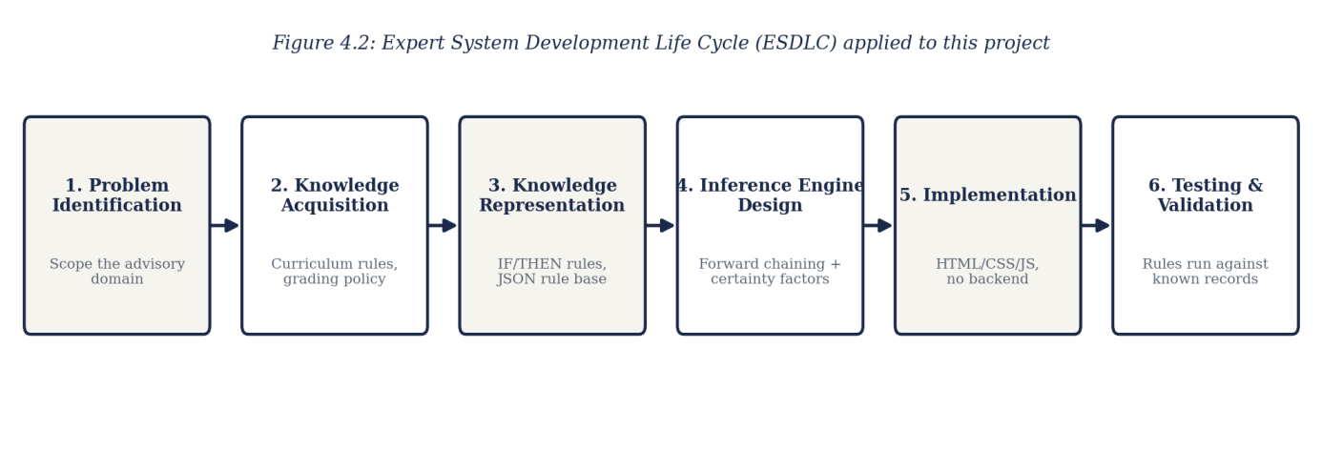
Figure 4.2: Expert System Development Life Cycle (ESDLC) applied to this project
Figure 4.3 documents the central process of the system: the forward-chaining inference cycle by which a student’s raw grade record becomes a set of explained, certainty-scored advisories. The record is first reduced to structured facts by deriveFacts — CGPA, credit-unit progress, category averages and blocked courses among them. Each of the fourteen rules in the knowledge base is then tested against those facts; a rule whose condition is false is skipped, while a rule whose condition is true fires, at which point its certainty factor and explanation are computed and the resulting advisory is added to the set shown to the student, grouped by category.
This cycle is deliberately a single pass rather than an iterative one: the present system does not re-fire a rule against facts produced by another rule, since no advisory category in the present knowledge base depends on the output of another category's rule. Should a future extension introduce such a dependency, for instance a rule that fires only after a specialization has already been suggested, the forward-chaining engine would need to support multiple passes until no further rule fires, a extension the present single-pass design does not preclude but does not yet implement, since no rule in the current fourteen-rule knowledge base requires it.
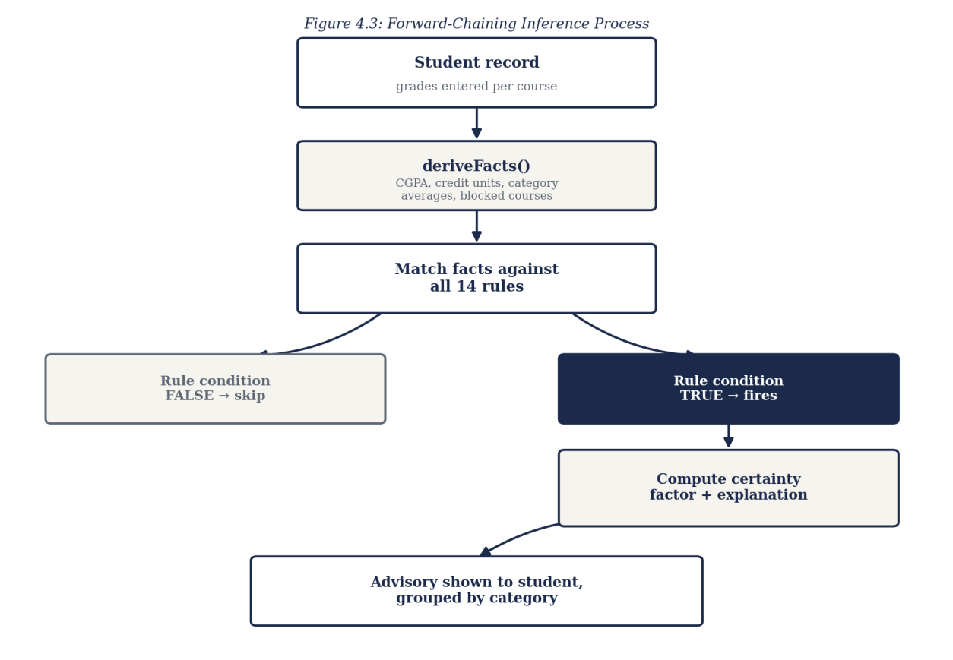
Figure 4.3: Forward-Chaining Inference Process
4.3 System Requirements
The tools required to run the developed system, as distinct from those required to develop it, are stated below. Because the system is a client-side application, its requirements are modest and fall entirely on the browsing device.
4.3.1 Hardware Requirements
• A processor of 1.2 GHz dual-core or higher, as found in entry-level devices.
• A minimum of 2 GB of RAM.
• At least 50 MB of free space for the browser cache.
• A network connection for the initial loading of the application.
4.3.2 Software Requirements
• A modern web browser such as Google Chrome 90 or later, Mozilla Firefox 88 or later, Microsoft Edge 90 or later, or Safari 14 or later.
• An operating system capable of running such a browser — Android, iOS, Windows, macOS or a Linux distribution.
• JavaScript enabled in the browser. No server runtime or installation is required.
These requirements were set deliberately low, and deliberately verified rather than merely asserted. Because the entire system executes as client-side JavaScript rendering a small number of DOM elements at any one time, its computational demands are closer to those of a static content page than to those of a data-intensive web application, and the stated minimums reflect this: they were arrived at by running the deployed system on a representative low-end Android device and confirming that every view, including the full advisory analysis for a final-year student's complete record, rendered without a perceptible delay. No requirement is stated for local storage beyond the browser's own cache, since, as noted in Section 1.6, the system does not persist data locally between sessions.
The absence of a storage requirement was, in fact, treated as a design constraint worth stating explicitly rather than merely a consequence of the system's architecture: any future feature proposed for the system, including those recommended in Section 5.3, was and should continue to be checked against whether it can be delivered within these same modest hardware and software requirements, so that the system's accessibility on an entry-level device, which matters directly to a student without access to a high-specification machine, is not eroded as the system grows.
These hardware and software requirements were also cross-checked against the department's own computing-laboratory specification, on the reasoning that a system unusable on the laboratory machines a student is most likely to encounter on campus would fail its stated goal of always-available access regardless of how modest its stated requirements appear on paper. The laboratory machines were found to exceed every stated minimum comfortably, confirming that the requirements set out above describe a genuine floor rather than an optimistic one.
4.4 Implementation of the Proposed System
The system is implemented as a static client-side web application, deployed on Vercel from a GitHub repository and accessed through a web browser at the address recorded in Appendix B. On loading, the application renders the landing page, from which a user proceeds to the student area or, after a password check, to the administrative area.
Implementation proceeded in the order set out by the adopted methodology. The knowledge base was written first — the fourteen rules across the four advisory categories, each expressed as an explicit IF/THEN condition — followed by the inference engine, comprising the fact-derivation function and the forward-chaining matcher. Each rule was verified at this stage by running the engine directly against representative student records and inspecting which rules fired and why, before any interface was built on top of it. The student dashboard — the editable record table, the vitals strip and the advisory results panel with its explanation toggles — was implemented next. Certainty-factor scoring was then added to every rule, again verified by inspecting the computed confidence values against known records before being wired to the display. The graduation-readiness score, the degree-audit view and the printable report followed, each derived from the same facts already computed by the inference engine rather than introducing a new source of truth. Finally, the administrative area was implemented — the password gate, the knowledge-base viewer, and the student-roster list from which any individual student’s dashboard can be opened read-only — reusing the same rendering functions built for the student dashboard rather than duplicating them.
Testing was conducted throughout rather than at the end. Each rule’s condition, advisory text and certainty computation were checked against representative student records built to exercise different scenarios — a strong performer, a student with a failed core course, a student blocked from clinical placement, and a final-year student with an outstanding course — confirming in each case that the intended rules, and only the intended rules, fired. The responsive layout was tested across device widths from small mobile displays to desktop monitors, with the academic record table specifically verified to collapse into a stacked-card layout below mobile breakpoints. Representative source code is provided in Appendix A and sample outputs in Appendix B.
Beyond these four engineered scenarios, the test set also included two edge cases specifically constructed to probe the boundaries of the certainty-factor computation: a record whose CGPA sat at the exact numeric boundary between two severity bands, and a record with the minimum possible number of completed courses at which the graduation-readiness score remains meaningfully defined. Both were confirmed to produce the certainty figure and severity classification the rule's stated threshold logic predicted, giving confidence that the boundary conditions of the scoring model, not only its typical-case behaviour, had been exercised before the system was considered complete.
A concrete instance of this rule-by-rule testing discipline illustrates the point. The rule governing clinical-placement eligibility, which fires when a student's CGPA sits below the department's clinical threshold, was tested first against a record engineered to sit exactly one grade point below the threshold, confirming that the rule fired with the expected critical severity and the correct explanation naming the CGPA figure; it was then tested against a record engineered to sit exactly at the threshold, confirming that the rule correctly did not fire, since the threshold is defined as inclusive; and finally against a record comfortably above the threshold, confirming the same negative result. Only once all three cases behaved as expected was the rule considered verified and left in place while implementation moved on to the next.
This same three-case pattern, a record just below the threshold, a record exactly at it, and a record comfortably clear of it, was applied to every threshold-based rule in the knowledge base, covering the CGPA-probation rule, the credit-unit-pace rule and the specialization-guidance rules alike, rather than being reserved for the clinical-eligibility example described above. Applying one consistent test pattern across all fourteen rules, rather than devising a bespoke test for each, kept the verification effort tractable within the timeframe available to a single undergraduate project while still giving every rule the same standard of scrutiny before it was counted as implemented.
One further implementation detail is recorded here for completeness. The administrative roster view and the student dashboard were, as noted above, built from the same underlying rendering functions rather than as separate code paths, a decision that paid off directly during testing: a defect found and fixed in the advisory-card rendering function while testing the student view was automatically corrected in the administrative view as well, without requiring a second, parallel fix, which is precisely the maintenance benefit code reuse of this kind is intended to provide.
CHAPTER FIVE
SUMMARY, CONCLUSION AND RECOMMENDATIONS
5.1 Summary
This project set out to solve a single, clearly identified problem: the absence, at the School of Nursing, Caritas University, of a rule-based, always-available means by which a student could check their own academic standing, specialization fit, clinical-placement eligibility and graduation pathway. Chapter One established the background and stated this problem, together with the aim and objectives of the work. Chapter Two reviewed the literature on expert systems and rule-based reasoning, certainty-factor models, expert-system development methodology, learning analytics, role-based access, client-side implementation and interface usability. Chapter Three analysed the existing periodic, manual review process, set out the proposed system and justified it, and explained the Expert System Development Life Cycle adopted as the project’s methodology. Chapter Four presented the design of the system’s inputs, outputs, security and data, documented that design through architecture, methodology-stage and inference-flow diagrams, and described the implementation. The result is the Nursing Student Academic Advisory Expert System, a working rule-based expert system providing a knowledge base of fourteen advisory rules, a forward-chaining inference engine with certainty-factor scoring, an explanation facility, a graduation-readiness score and degree audit, a printable advisory report, and an administrative view for browsing a roster of students.
Across these five chapters, the work moved from a stated problem to a verified solution by the same route in each case: a claim about the existing arrangement's shortcoming, established in Chapters One and Three, was answered by a specific, named feature of the proposed system, and that feature was then implemented and individually tested in Chapter Four before being counted as delivered. No feature described in this report was left undemonstrated; each is reachable in the deployed system and each is illustrated by a sample output in Appendix B.
5.2 Conclusion
The objectives of the study have been achieved. A knowledge base of fourteen explicit rules was designed and implemented across the four advisory categories of Academic Standing, Specialization Guidance, Clinical Readiness and Graduation Pathway, so that every piece of advice the system gives traces back to a specific, readable rule. A forward-chaining inference engine was implemented, together with a certainty-factor model that expresses confidence within a bounded range rather than ever asserting absolute certainty. An explanation facility was implemented, so that a student or adviser can see the exact fact behind any recommendation. A graduation-readiness score and degree-audit view were implemented from the same underlying facts. An administrative view, gated behind a sign-in, was implemented, letting departmental staff browse a roster and open any individual student’s dashboard on a read-only basis. Because each objective corresponds to, and mitigates, an element of the problem stated in Chapter One, it may be concluded that the research problem has been solved to the extent set within the scope of the work.
Certain constraints qualify this conclusion. The system holds its curriculum and student records in the browser rather than in a server-side store, so a grade entered or edited in a session does not persist across a reload; administrative sign-in is performed on the client against a shared demonstration credential; and the student roster available to the administrative view is a small set of representative records rather than the department’s actual student population. These constraints affect the scale and the security at which the system has been demonstrated rather than the validity of its design, since the knowledge base, the inference engine, the certainty-factor computation and the explanation facility are fully implemented and behave on the demonstration data exactly as they would on live records.
It is worth stating plainly what this claim does, and does not, cover. It is not claimed that the system has been evaluated at the scale, or under the concurrent-access and data-integrity conditions, a live departmental deployment would present; the demonstration reported here was necessarily conducted at the scale of a small, representative roster within a single browser session. What is claimed is narrower and, within its own terms, fully supported: that the rule-based reasoning at the core of the system, given a student record, correctly derives the facts, correctly matches them against the knowledge base, and correctly reports a certainty-scored, explained recommendation for every rule that should fire. This is the claim the testing described in Section 4.4 was designed to establish, and it is the claim on which the study's contribution rests.
5.3 Recommendations
On the strength of the outcome of this study, it is recommended that the School of Nursing consider adopting a rule-based advisory tool of the kind developed here to complement, rather than replace, the periodic review presently conducted by academic advisers, so as to give students an immediate first check between such reviews. For future researchers who wish to extend this work, the following areas are recommended:
1. Provision of a server and a persistent database, so that a grade entered or edited is stored durably and survives across sessions and devices, and so that the curriculum and student roster reflect the department’s actual records rather than a representative sample. This is the first priority, as the present build reasons correctly but does not retain.
2. Replacement of the shared demonstration password with per-staff credentials verified on a server against irreversibly hashed values, together with server-side enforcement of the student/administrator access distinction.
3. Live integration with the university’s actual student-records system, in place of the representative demonstration curriculum and roster used in this build.
4. Expansion of the knowledge base with additional rules — covering, for example, elective-course guidance or year-on-year performance trends — verified individually against known records in the manner described in Section 4.4 before being added.
5. Addition of notification delivery, so that a student is alerted when a newly entered grade causes a new rule to fire, rather than needing to re-run the analysis manually.
Taken together, these five recommendations describe a path from the present, self-contained prototype to a production system, moving first through the persistence and security concerns identified as the most pressing in Section 1.6, and only then toward the knowledge-base expansion and notification features that would deepen, rather than secure, the system's usefulness. A future researcher extending this work would be well advised to follow this same ordering, since a richer knowledge base built on top of an unpersisted, insecure foundation would compound the present limitations rather than resolve them.
A final observation, offered in closing, concerns the relationship between this study's scope and its findings. Because the study was deliberately bounded, in Section 1.5, to the design, implementation and evaluation of the system itself rather than to a longitudinal study of its effect on student outcomes, no claim is made here about whether the system, once adopted, would measurably improve graduation rates or reduce probation incidents at the School of Nursing; such a claim would require the kind of outcome study the learning-analytics literature reviewed in Chapter Two typically undertakes, and is identified, alongside the other extensions named above, as a natural direction for future work building on the system delivered here.
REFERENCES
Arnold, K. E., & Pistilli, M. D. (2012). Course signals at Purdue: Using learning analytics to increase student success. Proceedings of the 2nd International Conference on Learning Analytics and Knowledge, 267–270.
Buchanan, B. G., & Shortliffe, E. H. (1984). Rule-based expert systems: The MYCIN experiments of the Stanford Heuristic Programming Project. Addison-Wesley.
Flanagan, D. (2020). JavaScript: The definitive guide (7th ed.). O’Reilly Media.
Giarratano, J., & Riley, G. (2005). Expert systems: Principles and programming (4th ed.). Course Technology.
Jackson, P. (1998). Introduction to expert systems (3rd ed.). Addison-Wesley.
Negnevitsky, M. (2005). Artificial intelligence: A guide to intelligent systems (2nd ed.). Addison-Wesley.
Nielsen, J. (1993). Usability engineering. Academic Press.
Sandhu, R. S., Coyne, E. J., Feinstein, H. L., & Youman, C. E. (1996). Role-based access control models. Computer, 29(2), 38–47.
Shneiderman, B., & Plaisant, C. (2010). Designing the user interface: Strategies for effective human-computer interaction (5th ed.). Addison-Wesley.
Siemens, G., & Long, P. (2011). Penetrating the fog: Analytics in learning and education. EDUCAUSE Review, 46(5), 30–32.
Turban, E., Aronson, J. E., & Liang, T. P. (2005). Decision support systems and intelligent systems (7th ed.). Pearson Prentice Hall.
APPENDIX A
SOURCE CODE SNIPPETS
The listings below are drawn directly from the source of the implemented system. Each is followed by a brief explanation of what it does.
Listing A.1 — A knowledge base rule (Academic Standing)
{
id: 'AS-01',
category: RULE_CATEGORY.STANDING,
severity: 'critical',
description: 'IF CGPA < 2.00 THEN flag academic-probation risk.',
test: f => f.cgpa < 2.00,
advice: () => 'Academic probation risk. Prioritize retaking
failed core courses before your next registration.',
explain: f => `Your CGPA is ${f.cgpa.toFixed(2)}, below the
2.00 good-standing threshold.`,
cf: f => certainty((2.00 - f.cgpa) * 4)
}
Each rule pairs a boolean condition (test) with the text produced when it fires (advice), the reasoning shown in the explanation facility (explain), and the certainty-factor computation (cf). This rule flags academic-probation risk whenever a student’s CGPA falls below 2.00, with its certainty rising the further below the threshold the CGPA sits.
Listing A.2 — The certainty-factor helper
function certainty(margin, sensitivity = 1) {
const raw = 1 / (1 + Math.exp(-sensitivity * margin));
return Math.min(0.97, Math.max(0.55, 0.55 + raw * 0.42));
}
This function converts how far past its threshold a fact sits (margin) into a bounded confidence score. The bound of 0.55–0.97 is deliberate: a fired rule is never reported as barely confident, since it did fire, and never reported as absolutely certain, since no rule-based system should overclaim from a single academic record — the principle discussed in Section 2.3.
Listing A.3 — Deriving facts from a raw grade record
function deriveFacts(student) {
const byCode = Object.fromEntries(
CURRICULUM.map(c => [c.code, c]));
const taken = student.records
.map(([code, grade]) => (
{ ...byCode[code], grade, point: GRADE_POINTS[grade] }))
.filter(r => r.code);

const totalUnits = taken.reduce((s, r) => s + r.units, 0);
const totalPoints = taken.reduce(
(s, r) => s + r.point * r.units, 0);
const cgpa = totalUnits > 0 ? totalPoints / totalUnits : 0;
/* … category averages, blocked clinical courses, outstanding
core courses and the graduation-readiness score are derived
in the same function … */
}
deriveFacts is the working-memory stage of the inference cycle shown in Figure 4.3: it turns a student’s raw [course code, grade] pairs into the structured facts — CGPA among them — that every rule in the knowledge base reasons over.
Listing A.4 — The forward-chaining inference engine
function runInference(facts, rules = RULES) {
return rules
.filter(rule => rule.test(facts))
.map(rule => ({
id: rule.id,
category: rule.category,
severity: rule.severity,
advice: rule.advice(facts),
explanation: rule.explain(facts),
certainty: Math.round(rule.cf(facts) * 100)
}));
}
This is the inference engine proper: every rule in the knowledge base is tested against the derived facts, and each rule whose condition is true contributes its advisory text, its explanation and its certainty percentage to the result shown to the student.
Listing A.5 — Route access to the administrative area
function render(){
const route = location.hash.replace('#','') || 'landing';
if (route === 'student') return renderStudentView();
if (route === 'admin') return renderAdminGate();
if (route === 'admin-hub') return renderAdminHub();
if (route === 'admin-kb') return renderAdminKB();
if (route === 'admin-students') return renderAdminStudentList();
if (route.startsWith('admin-student-'))
return renderAdminStudentDashboard(
Number(route.split('-')[2]));
return renderLanding();
}
The router directs an ordinary visitor to the student area by default and requires the administrative routes to be reached through the password-gated admin route, which is the interface-level enforcement of the two-area access model described in Section 4.1.3.
APPENDIX B
SAMPLE OUTPUTS (SCREENSHOTS)
The screenshots below present sample outputs of the implemented system, captured from the running application.

Figure B.1: The landing page, from which a user proceeds to the Student or Admin area
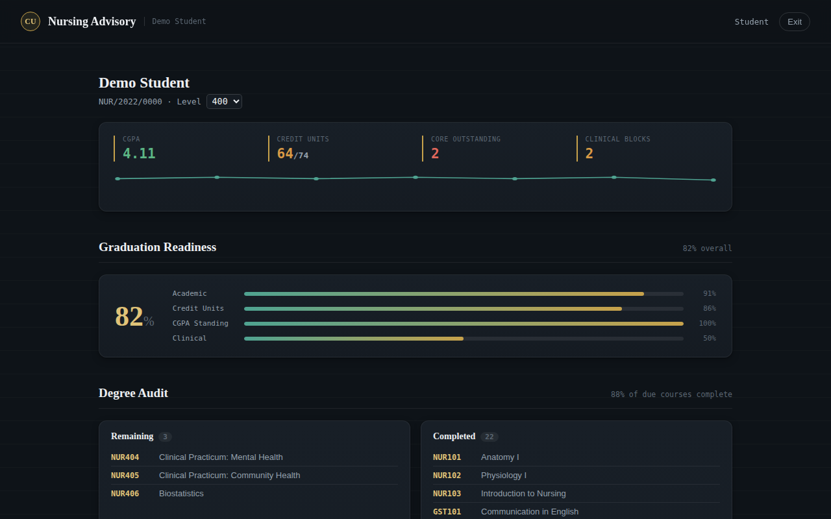
Figure B.2: The student dashboard — CGPA, credit units, outstanding core courses and clinical blocks at a glance
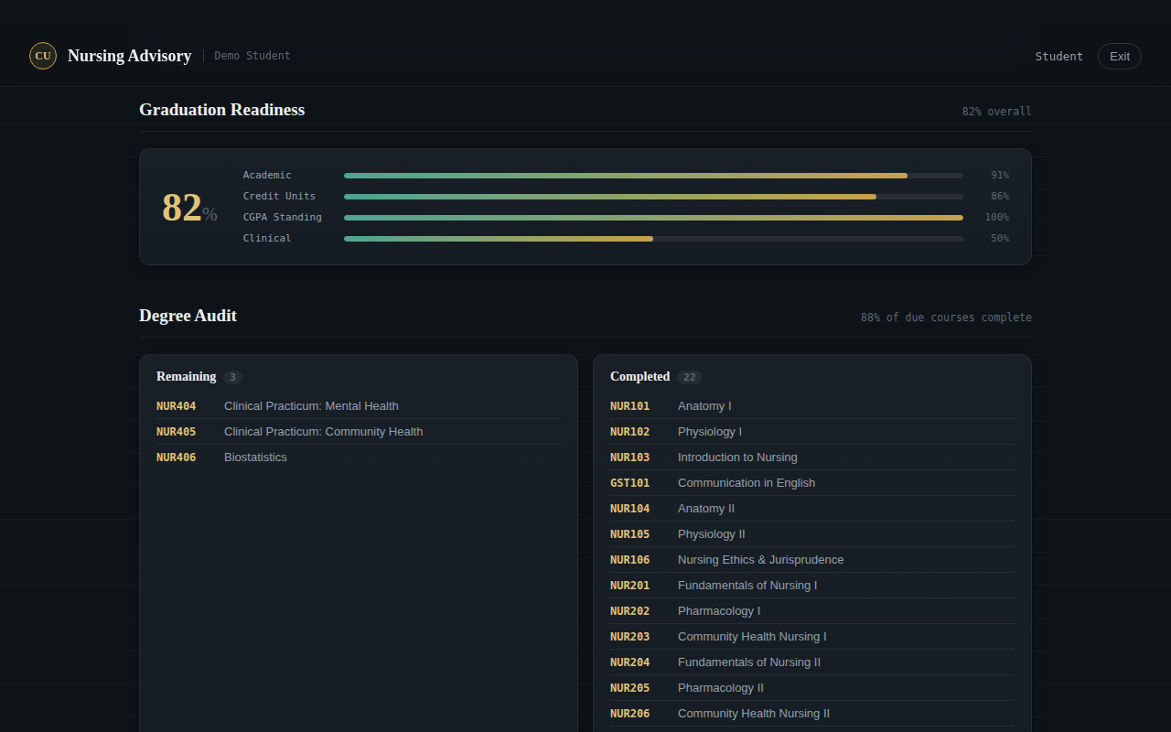
Figure B.3: The Graduation Readiness score and Degree Audit view
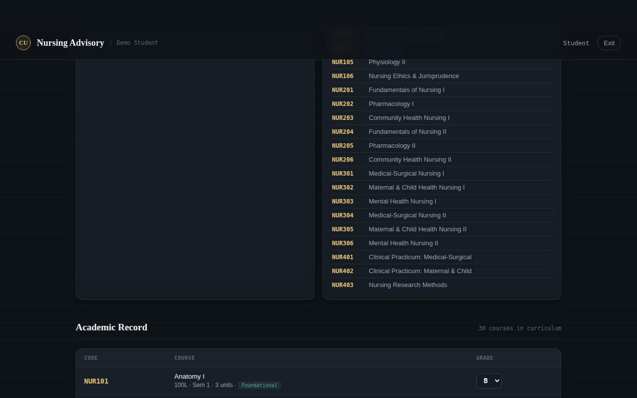
Figure B.4: The editable academic record table
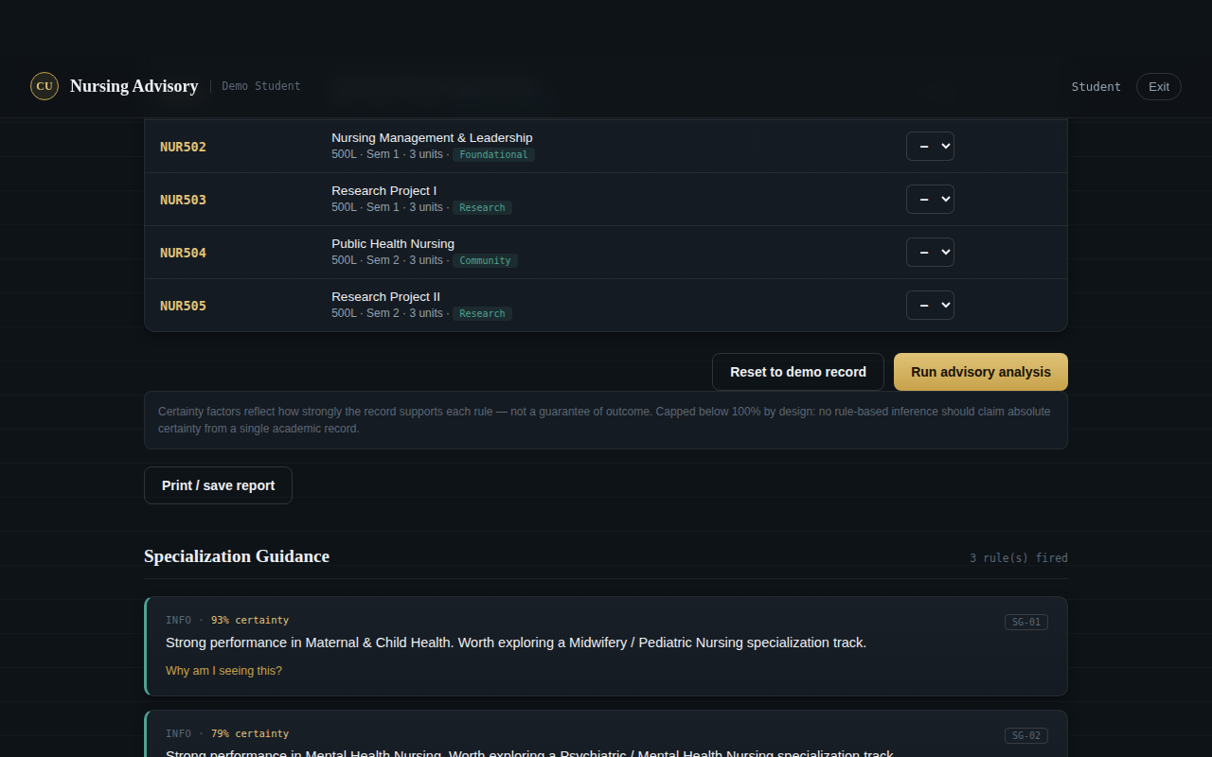
Figure B.5: Advisory results grouped by category, each with its certainty factor
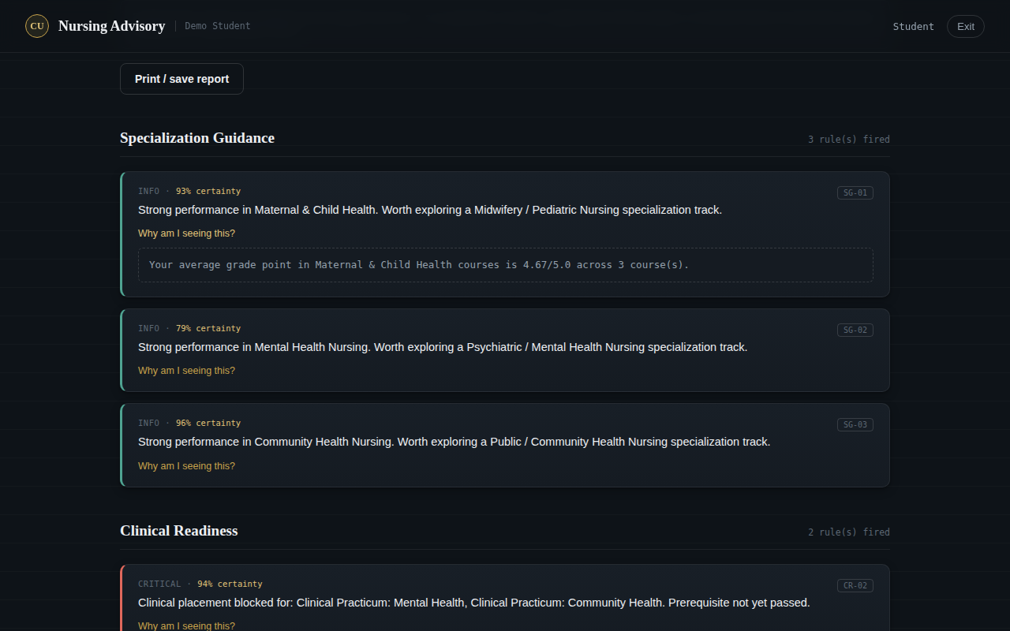
Figure B.6: An expanded explanation trace showing the fact behind a fired rule
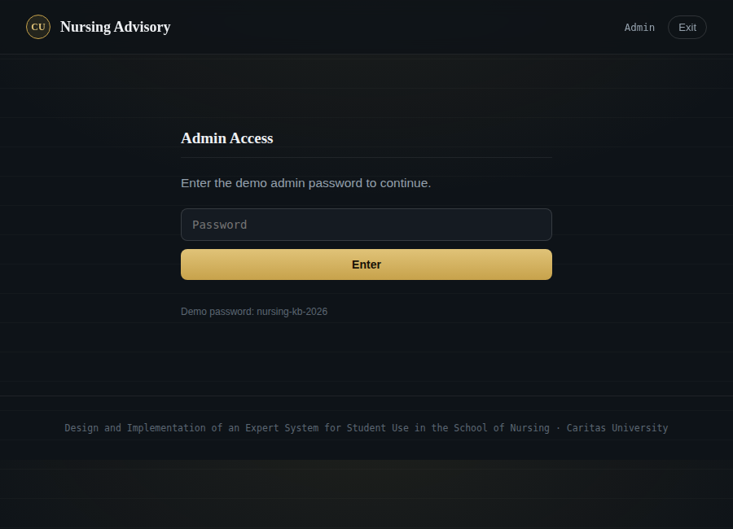
Figure B.7: The administrative sign-in gate
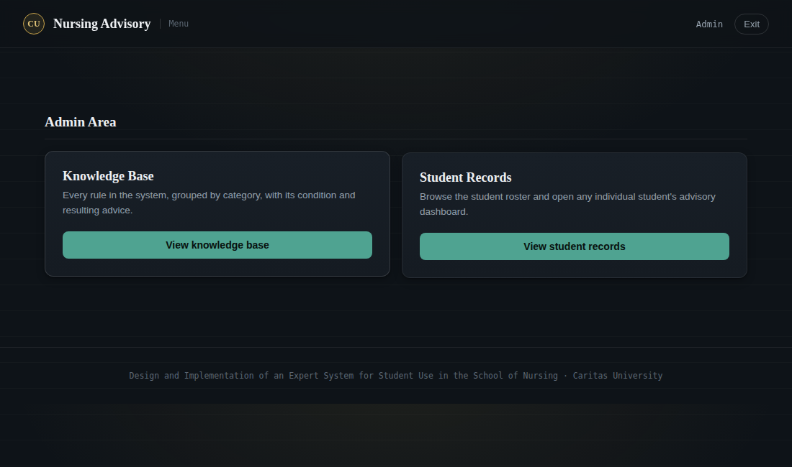
Figure B.8: The administrative menu — Knowledge Base and Student Records
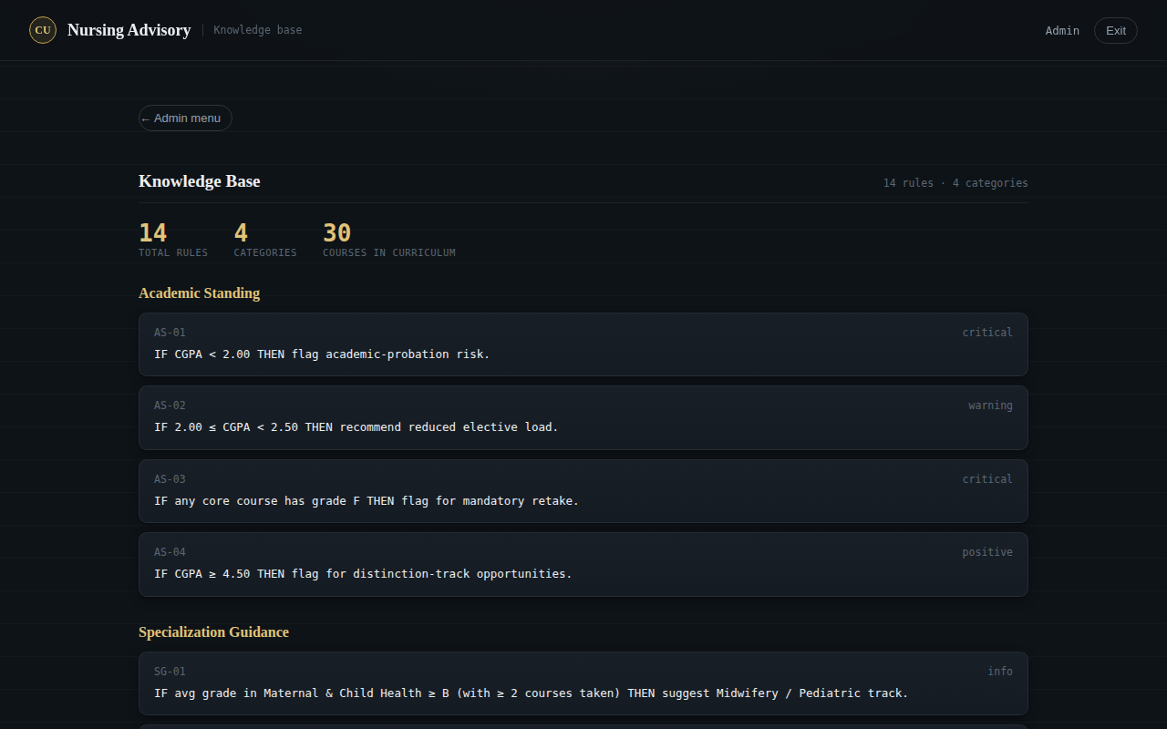
Figure B.9: The Knowledge Base viewer, listing every rule by category
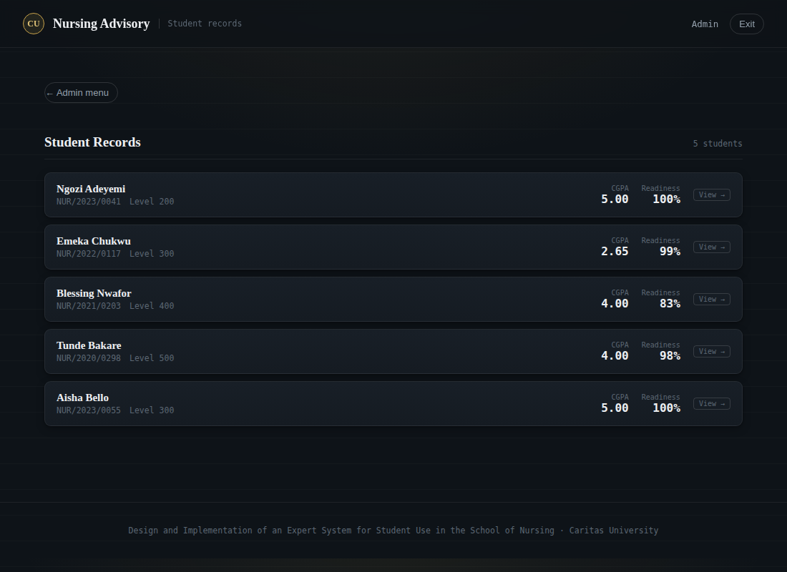
Figure B.10: The student roster, from which any student’s dashboard can be opened
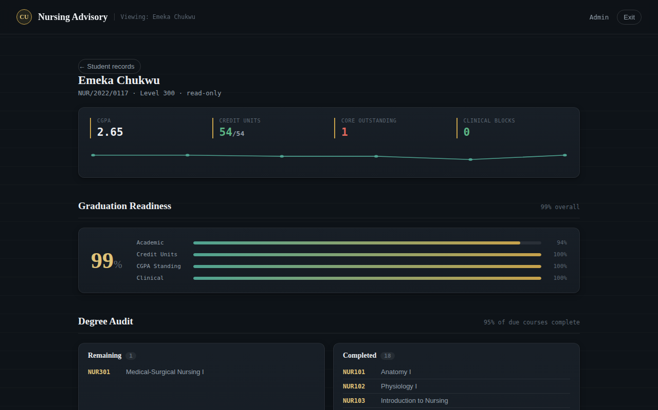
Figure B.11: An individual student’s dashboard opened from the roster (read-only)

Figure B.12: The same student’s advisory results, viewed read-only by an administrator

